Project Documentation

Cook Book – Your Virtual Kitchen Assistant

Project Title: Cook Book – Your Virtual Kitchen Assistant

Team ID: NM2025TMID47702

Team Leader : Ranjini.P & ranjini275.rs@gmail.com

Team Members:

Revathi.A & revathi06122006@gmail.com

Sagana S & Ssaganasagana01@gmail.com

Sandhiya.K & Ksandhiya619@gmail.com

- Introduction

your guide to accessible, healthy, and community-driven cooking
• Accessible Culinary Knowledge – Provides easy-to-follow recipes and cooking guidance for all skill levels, anytime and anywhere.
• Promotes Healthy Eating – Encourages balanced meals and nutrition-focused recipes to improve lifestyle and wellbeing.
• Community Building – Connects food enthusiasts to share recipes, tips, and cultural food experiences.

- Social Impact

- Digital access to recipe
- for all demographics

- Affordable healthy food guidance

Method: This project empowers people of all backgrounds by making culinary knowledge universally accessible. It reduces barriers to learning cooking skills, helping communities fight malnutrition, food waste, and unhealthy eating habits.

- Accessible culinary knowledge

- Step-by-step tutorials

- Regional & cultural recipe libraries

- Voice/text/video accessibility features

Method: The platform ensures that anyone—beginners, differently-abled individuals, or busy professionals—can easily learn and enjoy cooking. Recipes are simplified and enriched with multimedia to make learning intuitive and fun.

- Promotes Healthy Eating

- Nutritional breakdown of recipes

- Diet-based recommendations

- Portion control and meal planning tools

Method: By integrating nutrition science, the assistant encourages balanced diets. Users are guided toward healthier alternatives, while still enjoying taste and variety in their meals.

- Community Building

- Recipe sharing features

- Local food forums & discussions

- Collaboration with chefs, nutritionists, and home cooks

Method: Users don’t just cook—they connect. The assistant creates a community space where food knowledge flows, fostering cultural exchange, peer learning,
and stronger food communities.

- Business Model / Impact

- Freemium subscription model

- Premium personalized diet/cooking plans

Method: Sustainable monetization ensures long-term growth. Partnerships with food and wellness industries amplify reach while maintaining a strong focus on social good.

- Existing Solutions

- Git Hub Link [ https://github.com/ranjini2727/Cookbook-.git ]

- Recommended Technology stack

- AI-driven personalization

- Accessibility-first design

- Verified nutrition data integration

Method: Enhancing beyond current solutions by merging technology, inclusivity, and health awareness into one platform.

- Architecture
• Frontend: React.js with Bootstrap and Material UI
• Backend: Node.js and Express.js managing server logic and API endpoints
• Database: MongoDB stores user data, recipes, preferences, and meal plan

- Setup Instructions
• Prerequisites:
– Node.js
–– Git
– React.js
– Express.js
– Visual Studio Code
• Installation Steps:
# Clone the repository: git clone <repository_url>
# Install client dependencies: cd client && npm install
#Install server dependencies: cd ../server && npm install

- Running the Application

• Frontend: cd client && npm start
• Backend: cd server && npm start
• Access: Visit http://localhost:3000
MongoDB

API Documentation
• User: /api/user/register, /api/user/login
• Recipes: /api/recipes/create, /api/recipes/:id
• Meal Plans: /api/mealplans/create, /api/mealplans/:id

- Authentication

• JWT-based authentication for secure logic

- User Interface

• Landing Page
• Recipe Dashboard
• Meal Planner

• User Profile Middleware protects private routes

- Testing

• Manual testing during milestones
• Tools: Postman, Chrome Dev Tools

- Screenshots or Demo

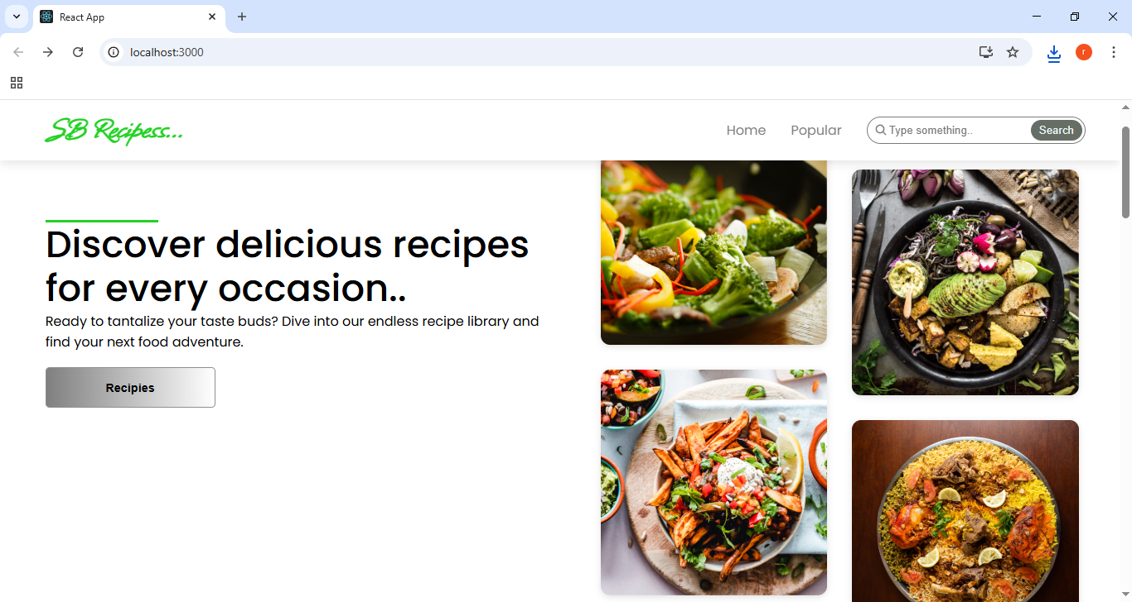

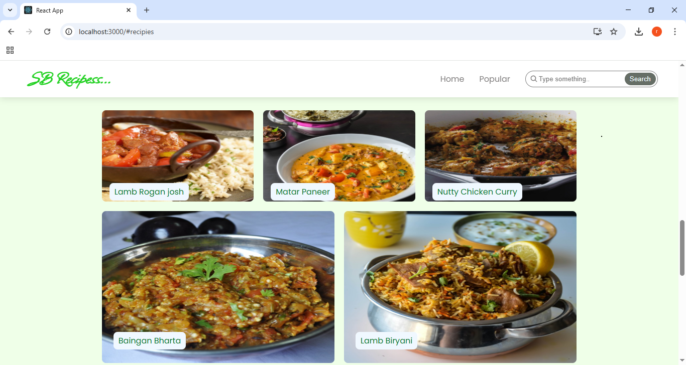

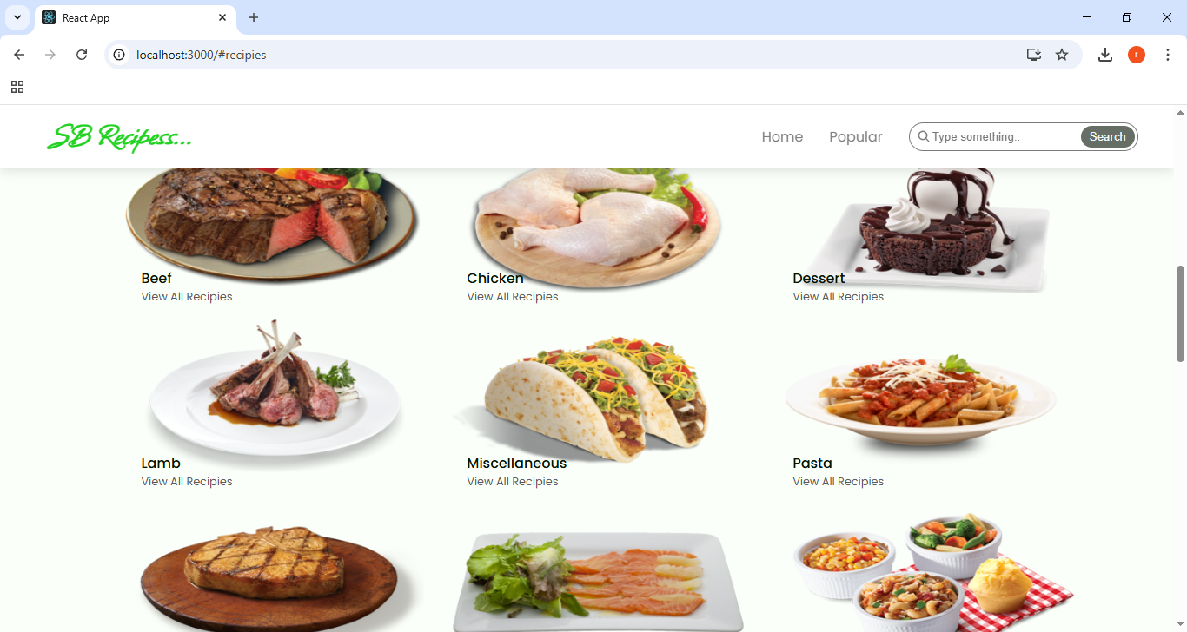

Known Issues

• Limited Recipe Database – Not all cuisines or dietary preferences are currently covered.
• Ingredient Availability – Some recipes may include ingredients that are hard to find in certain regions.
• Measurement Inconsistencies – Recipes may use different units (grams, cups, spoons), causing confusion.

- Future Enhancements

• Offline Access – Enable users to download recipes and access them without internet.
• Nutritional Analysis – Provide detailed calorie counts and macro breakdowns for each recipe.
• Voice Assistant Support – Step-by-step cooking guidance through voice commands.
• Shopping List Generator – Automatically create a grocery list from selected recipes

